RED KNIGHTS MOTORCYCLE CLUB ®
Germany XVI
Tim “Timme” Bruderhans - QUARTERMASTER
Vahrenkamp 4
49424 Goldenstedt, Niedersachsen, Germany
Tel. +491701984707
E-Mail: quartermaster@red-knighst-mc-germay-16.de
TMLA File Number Germany 16-12

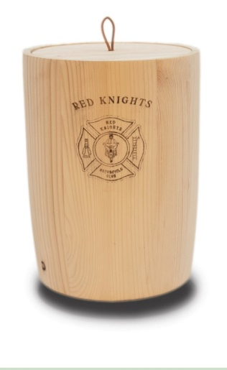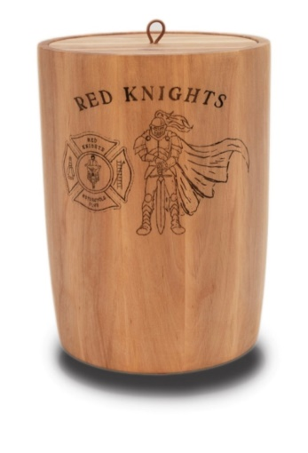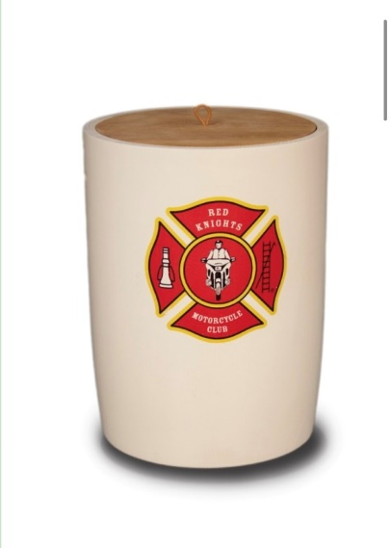
Option #1 Option #2 Option #3 Option #4

- natural wood - certified wood, FSC
- Craftsmanship - inside 17.5 cm x 23 cm suitable for an ash capsule
- 100% made in Germany - the drainage cord is made of natural fiber
- fully biodegradable

☐Automotive
☐Automotive-Misc
☐Automotive-Motorcycle
☐Coin, Patches, Pins
☐Clothing
☐Clothing-Hats
☐Clothing-Misc
☐Clothing-Vest/Vest Items
☐Clothing-Women’s
☐Decals/Stickers
☐Flags
☐Housewares-Beverage Items
☐Housewares-Misc.
☒Misc. Items

Item | Description | Color | Quantity | Cost ea. | Total
1 | Wooden Grave Urn Option #1 |  |  | 290 €
2 | Wooden Grave Urn Option #2 |  |  | 320 €
3 | Wooden Grave Urn Option #3 |  |  | 310 €
4 | Wooden Grave Urn Option #4 |  |  | 430 €
Sub Total
Shipping and handling fees (if any) |  |  |  |  | 20 €
Total
Please make check/money order out to quartermaster@red-knights-mc-germany-16.de
Please allow 6-8 weeks for delivery of items not in stock
All Prices Euro currency / Prices subject to change without notice/All items MUST be prepaid

